SKILL 15 : INVERT SUBJECT AND VERB WITH QUESTION WODS

Subject and verb dapat di ‘tukar’ dalam beberapa kondisi. Subject dan helping verb biasanya di ‘tukar’ dalam format kalimat tanya. Helping Verb yang dimaksud adalah be, have, can, could, will, would, dst.
- He can go to the movies
- Can he go to the movies?
- He is ok
- Is he ok?
Apabila tidak menggunakan helping verb diatas maka kita dapat menggunakan do, does, did
- He goes to the movie
- Does he go to the movie?
- He went to the movie
- Did he go to the movie?
Penukaran antara subject dan verb dalam WH-question dapat memiliki lebih dari 1 pola perhatikan contoh :
- what is the homework?
- where are you going?
- I do not know what the homework is
- Do you know where you are going
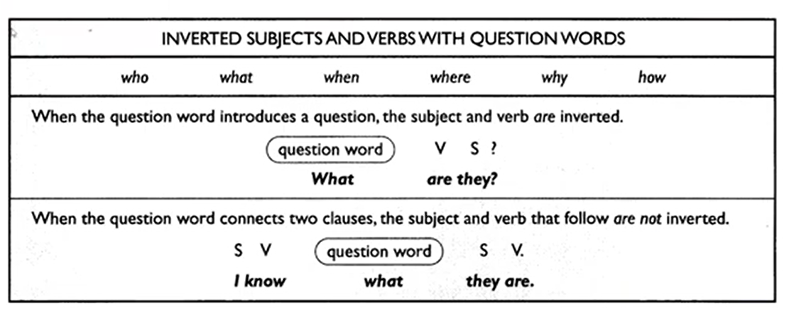
Contoh dalam soal TOEFL :
The lawyer asked the client why ___ it?
- Did he do
- Did he
- He did
- Did

Choose ‘correct’ or ‘incorrect’ for the following sentences
- The phone company is not certain when will the new directories be ready
- Correct
- Incorrect
- The professor does not understand why so many students did poorly on exam
- Correct
- Incorrect
- How new students can get information about parking?
- Correct
- Incorrect
- Where is the cheapest to get typeset copies printed?
- Correct
- Incorrect
- Only the pilot can tell you how far can the plane go on one tank of fuel
- Correct
- Incorrect

SKILL 16 : INVERT THE SUBJECT AND VERB WITH PLACE EXPRESSION

kalimat yang memuat keterangan tempat kadang subject dan verb dapat ditukar. Yang paling umum, ketika menggunakan kata seperti here, there, nowhere.
- Here is the book that you lent me
- There are the keys that I thought I lost
Subject dan verb juga dapat ditukar setelah prepositional phrases expressing place. Contoh :
- In the closet are the clothes that you want
- Around the corner is Sam’s house
- Beyond the mountains lies the town where you will live

CATATAN! Penukaran antara subject dan verb dapat dilakukan hanya apabila prepositional phrases of place tersebu digunakan untuk melengkapi kalimat. Contoh :
- In the forest are many exotic birds
- In the forest I walked for many hours

Contoh dalam soal TOEFL :
On the second level of the parking lot ___ .
- Is empty
- Are empty
- Some empty stalls are
- Are some empty stalls
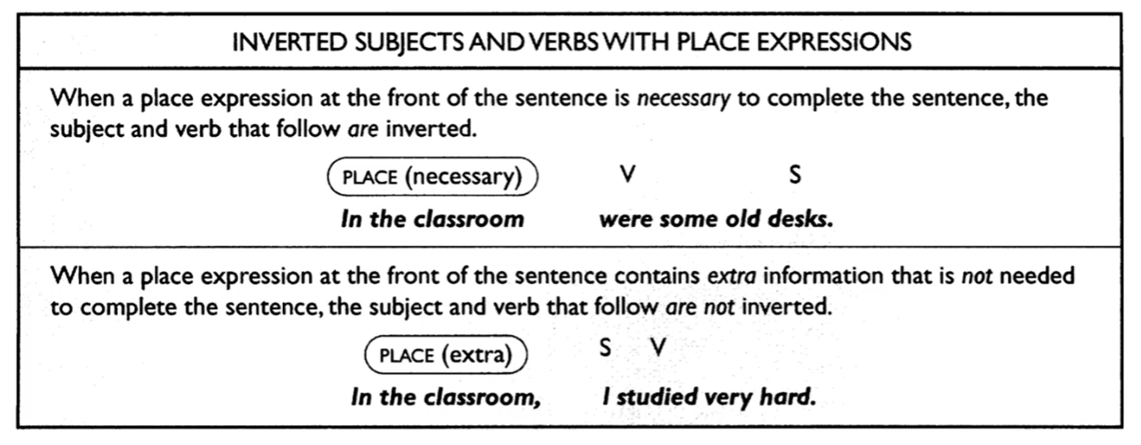

Choose ‘correct’ or ‘incorrect’ for the following sentences
- In front of the house were some giant trees
- Correct
- Incorrect
- There a big house is on the corner
- Correct
- Incorrect
- In the cave was a vast treasure of gems and jewels
- Correct
- Incorrect
- To the north the stream is that the settlers will have to cross
- Correct
- Incorrect
- Around the corner are the officers that you are trying to find
- Correct
- Incorrect

SKILL 17 : INVERT THE SUBJECT AND VERB WITH NEGATIVES

Subject dan verb dapat ditukar tempatnya setelah beberapa ekspresi yang memuat makna negative. Ketika awal kalimat memuat no, not never maka subject dan verb ditukar. Contoh :
- Not once did I miss a question
- Never has Mr. Jones taken a vacation
- At no time can the woman talk on the telephone
Selain contoh diatas ada juga hardly, barely, scarcely, only juga dapat diartikan sebagai negative. Contoh :
- Hardly ever does he take time off
- Only once did the manager issue overtime paychecks
Ketika makna negative ada ditengah juga bisa dilakukan penukaran antara subjcet dan verb. Seperti penggunaan niether atau nor
- I do not want to go, and neither does Tom
- The secretary is not attending the meeting, nor is her boss

Contoh dalam TOEFL :
Only in extremely dangerous situations ___ stopped
- Will be the printing presses
- The printing presses will be
- That the printing presses will be
- Will the printing presses be
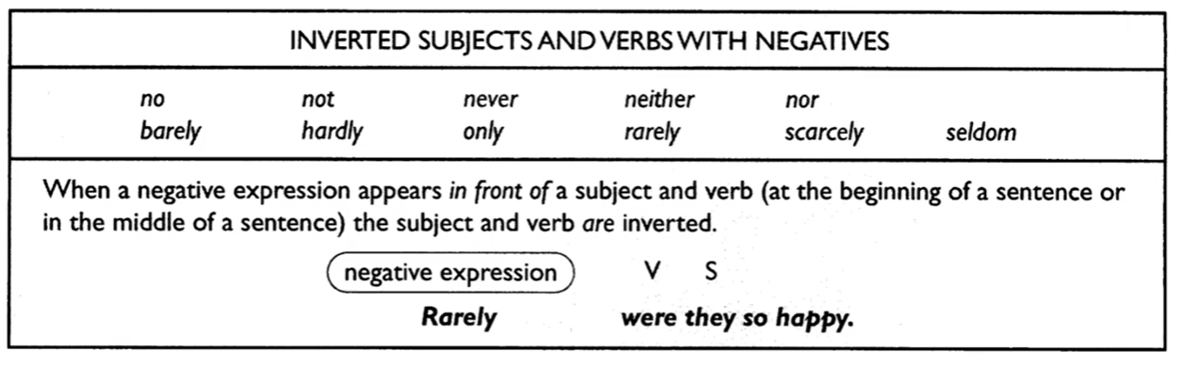
Choose ‘correct’ or ‘incorrect’ for the following sentences
- Never the boy wrote to his sister
- Correct
- Incorrect
- On no occasion did they say that to me
- Correct
- Incorrect
- Steve did not win the prize, nor did he expect to do so
- Correct
- Incorrect
- Only once in my life gone I have to New York City
- Correct
- Incorrect
- Did he go out of the house at no time
- Correct
- Incorrect

SKILL 18 : INVERT THE SUBJECT AND VERB WITH CONDITIONALS

Dalam beberapa conditional sentence subject dan verb juga dapat ditukar. Hal bisa dilakukan apabila helping verb nya adalah had, should, were maka conditional connector yaitu if dihilangkan. Contoh :
- If he had taken more time, the results would have been better.
- Had he taken more time, the results would have been better
- I would help you if I were in a position to help
- I would help you were I in a position to help
- If you should arrive before 6.00, just give me a call
- Should you arrive before 6.00, just give me a call

Soal dalam TOEFL :
The report would have been accepted ___ in checking its accuracy
- If more care
- More care had been taken
- Had taken more care
- Had more care been taken
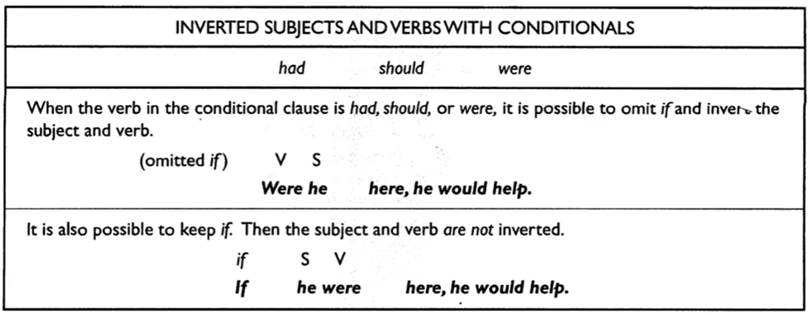
Choose ‘correct’ or ‘incorrect’ for the following sentences
- Were our neighbours a bit more friendly, it would be somewhat easier to get to know them
- Correct
- Incorrect
- There are plenty of blankets in the closet if should you get cold during the night
- Correct
- Incorrect
- Has he enough vacation days left this year, he will take two full weeks off in December
- Correct
- Incorrect
- Had we been informed of the decision, we might have had something to say about it
- Correct
- Incorrect
- I would like to know could you help me packed these boxes
- Correct
- Incorrect

EVALUASI SKILL 15 – 18

Choose ‘correct’ or ‘incorrect’ for the following sentences
- What type of security does he prefer for his investments?
- Correct
- Incorrect
- Not even the bank president knows when the vault will be opened
- Correct
- Incorrect
- How long it has been since you arrived in the United States
- Correct
- Incorrect
- The jury doubts what the witness said under cross-examination
- Correct
- Incorrect
- Do you know why he wants to take an extended leave of absence?
- Correct
- Incorrect
- At the Italian restaurant was the food to spicy for my taste
- Correct
- Incorrect
- Nowhere in the world farmers can grow such delicious food
- Correct
- Incorrect
- In the backyard the two trees are that need to be pruned
- Correct
- Incorrect
- Around the recreation hall and down the path are the tents where we will be staying this week
- Correct
- Incorrect
- In the apartment next to mine a man and a woman were having a heated discussion
- Correct
- Incorrect
- Seldom their secretary has made such mistakes
- Correct
- Incorrect
- No sooner had she hung up the phone than it rang again
- Correct
- Incorrect
- Shiela did not arrive late for work, nor she left early
- Correct
- Incorrect
- Barely had he finished the exam when the graduate assistant collected the papers
- Correct
- Incorrect
- The police did not arrive in time to save the girl, and neither did the paramedics
- Correct
- Incorrect
- He would have been in big trouble had not he remembered the assignment at the last minute
- Correct
- Incorrect
- If your friends come to visit, will they stay in a hotel or at your house?
- Correct
- Incorrect
- He might be a little more successful today were he a little more willing to do some hard work
- Correct
- Incorrect
- Should you ever visit this town again, I would be delighted to show you around
- Correct
- Incorrect
- Do you think that she would give the speech were she asked to do so?
- Correct
- Incorrect

